Custom Date Picker
Past date disabled including upcoming Saturday and Sunday.
<c-custom-date-picker-cmp
place-holder="00/00/0000"
min-date={minDate}
max-date={maxDate}
min-year={minYear}
max-year={maxYear}
days-disabled={daysDisabled}
mode="default"
ondateselect={handleDateSelect}>
</c-custom-date-picker-cmp>

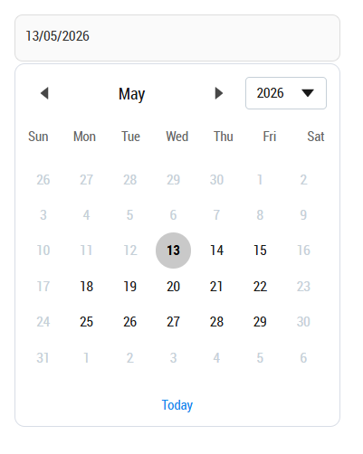
New only today allowed.
<c-custom-date-picker-cmp
place-holder="00/00/0000"
mode="pastAndFuture"
ondateselect={handleDateSelect}>
</c-custom-date-picker-cmp>

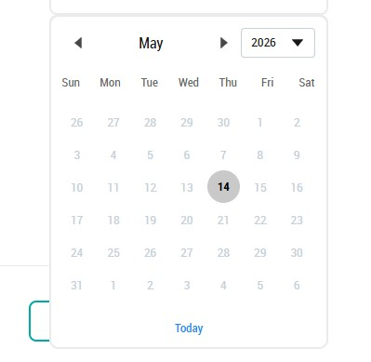

If only past disabled needed
<c-custom-date-picker-cmp
place-holder="00/00/0000"
mode="pastOnly"
ondateselect={handleDateSelect}>
</c-custom-date-picker-cmp>

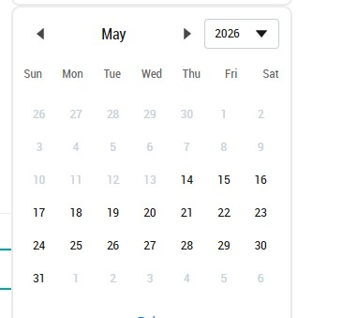

Calendar filed and calendar coming from the component.
Parent Component (HTML)
<c-custom-date-picker-cmp
min-date={minDate}
max-date={maxDate}
min-year={minYear}
max-year={maxYear}
days-disabled={daysDisabled}
ondateselect={handleDateSelect}
ontodaydateselect={handleDateSelect}
</c-custom-date-picker-cmp>

Parent Component (JS)
minDate=new Date(2026, 0, 20); //YYYY, mm, dd
maxDate=new Date(2026, 8, 7); //YYYY, mm, dd
minYear= '2020';
maxYear= '2030';
daysDisabled=[0,6];

SET DATE RANGE

minDate and maxDate used to set the date range of calendar. If left blank it will show fullyear calendar.[optional]

If minDate would be current date in that case, we need to use below code:
connectedCallback(){
const today = new Date();
this.minDate = new Date(today.getFullYear(), today.getMonth(), today.getDate());
}

SET YEAR CHANGE

minYear and maxYear used to set the Year range in year selection dropdown.[optional]

SET DAYS DISABLED

daysDisabled used to disable the days in a week.
Eg. If we need to disable SUN in whole calendar we need to pass the value in arrray format. We can select multiple days. [0,6] sat,sun disable

SUN == 0
MON == 1
TUE == 2
WED == 3
THU == 4
FRI == 5
SAT == 6

GET VALUE ON PARENT

handleDateSelect(event) {
const rawDate = event.detail.value;
const formattedDate = event.detail.formattedDate;

console.log('Raw:', rawDate);
console.log('Formatted:', formattedDate);

}

Used this function on parent to get the date field value on parent

Below css code should be attach in static resource file:
/*--date-wrapper--*/
.date-wrapper .prevMonth svg,
.date-wrapper .nextMonth svg,
.date-wrapper .prevMonth .slds-button:hover svg,
.date-wrapper .nextMonth .slds-button:hover svg,
.date-wrapper .prevMonth .slds-button:focus svg,
.date-wrapper .nextMonth .slds-button:focus svg{
width: 16px;
height: 16px;
fill: #474747;
display: inline-block;
overflow: visible;
}
.date-wrapper .prevMonth .slds-button,
.date-wrapper .nextMonth .slds-button{
background: transparent !important
}

.date-wrapper .prevMonth .slds-button[:disabled],
.date-wrapper .nextMonth .slds-button[:disabled]{
fill: #C6D0D8;
}
.year-dropdown .trigger svg{
fill: #181818;
width: 16px !important;
}

